Gaussian Filter

[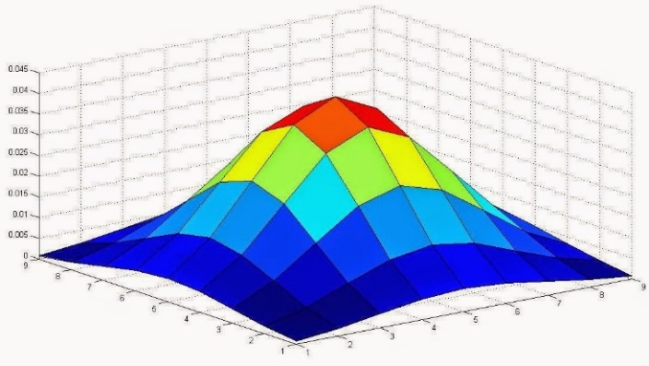](https://1.bp.blogspot.com/-smik2mDO1tY/U1rg1M9o6LI/AAAAAAAABEc/Av5WicVv0bs/s1600/Gaussian_filter.jpg)

Gaussian Filter is used to blur the image. It is used to reduce the noise and the image details.

[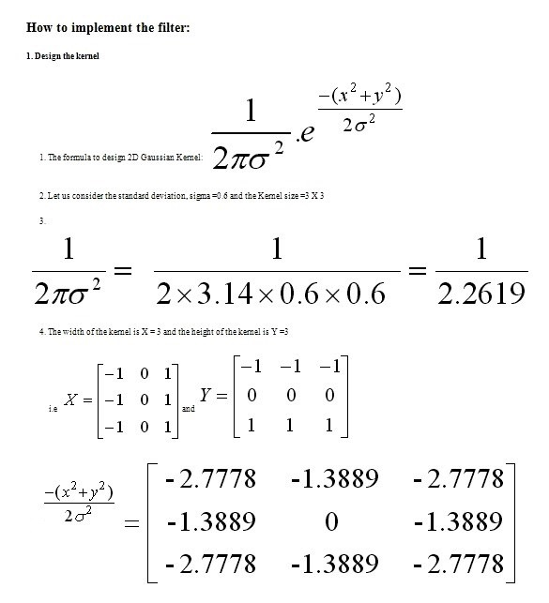](https://3.bp.blogspot.com/-t-xFnSbnwLs/WjcStQxXCLI/AAAAAAAAB8E/xsz0RLjqorsNE5Bv_MkjMzSAjI81gUklwCLcBGAs/s1600/gauss01.jpg)

          The Gaussian kernel's center part (Here 0.4421) has the highest value and  intensity of other pixels  decrease as the distance from the center part increases.

[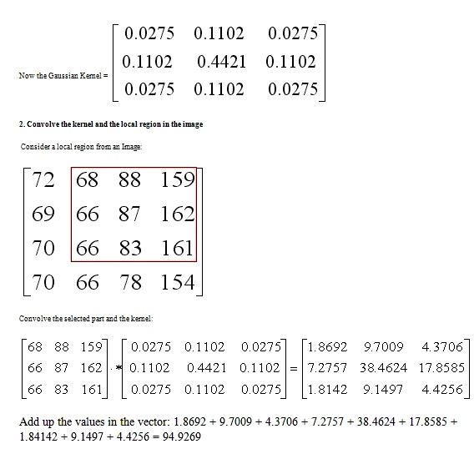](https://2.bp.blogspot.com/-ci1ZJ3pqLww/WjcR6rScEdI/AAAAAAAAB78/ck7RY8EKJlgeNs4ZUHUZhYeU9glchxrAACLcBGAs/s1600/gauss02.jpg)

      On convolution of the local region and the Gaussian kernel gives the highest intensity value to the center part of the local region(38.4624) and the remaining pixels have less intensity as the distance from the center increases.

      Sum up the result and store it in the current pixel location(Intensity = 94.9269) of the image.

[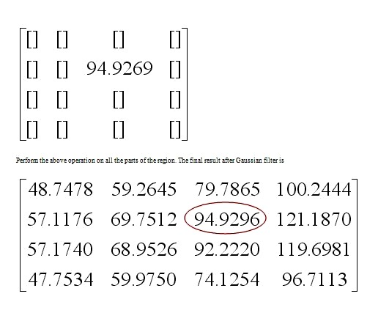](https://3.bp.blogspot.com/-c9_ILWiGDtk/WjcR6NQgwzI/AAAAAAAAB70/DagNPSZbNKg5P-nl5d30uXZEMIg5MCc-wCEwYBhgL/s1600/gauss03.jpg)

|  |
| --- |
| <https://1.bp.blogspot.com/-mVSoLpGl4U8/U1rhyVcgVaI/AAAAAAAABE8/ULoILDvdUr0/s1600/Gaussian_noise.jpg> |
| Image with Noise |

|  |
| --- |
| <https://4.bp.blogspot.com/-7y7G_hLj0sE/U1rfjl_JM1I/AAAAAAAABEU/IYt3iRKrM-A/s1600/Gaussian+Kernel.jpg> |
| Gaussian Kernel 9x9 size with Standard Deviation =1.76 |

|  |
| --- |
| <https://3.bp.blogspot.com/-c-Z2ax29e30/U1rh8gcIS6I/AAAAAAAABFE/RJxHFuixFRA/s1600/Gaussian_blur.jpg> |
| After Filtering |